- Woodwind
Long ago, all instruments from this family were made of wood, but now some of them are made from metal combined with other material. The wind part refers to the wind that comes from our breath that we blow into the intruments that makes the intruments sound well. These intruments, except flute, use a thin piece of wood called a reed which vibrates when the player blows across it. The sound happens when the air vibrates inside. Their uniqueness from the other family is their shape.

Here are some music instruments from the woodwind family
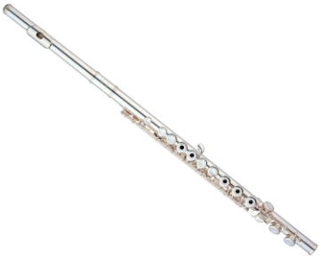
Flutes are usually made from silver, gold or other material such as metal. A standard flute is around 27 ½ inches long. It uses 2 clefs, which are G clef and C clef. There are 2-4 flutes in an orchestra. The standard one is the C Clef. It is the most brilliant and agile of the orchestral woodwinds and it also has a considerable solo and chamber-music literature. The tone of all flutes is produced by an airstream directed against an edge, producing eddies that set up vibrations in the air enclosed in the attached tube. We play the flute by holding it sideways with both hands and blowing across a hole. We use our fingers to open and close the keys, which changes the pitch of the sounds.

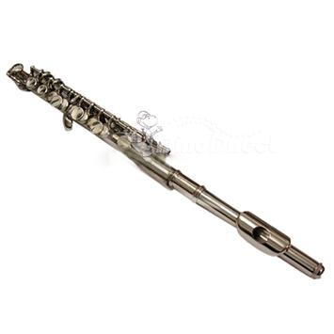
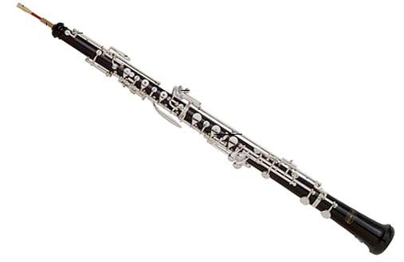
Oboe is a long slender black tube with metal keys. Oboe has a double reed, two pieces of wood tied together that look like a flattened straw. There are 2-4 oboes in an orchestra. A standard oboe is 2 feets long. To play it, we hold the oboe in up and down position, put the end of the double reed in our mouth and blow. We use both hands to press on the keys to open and close the holes, and change the pitch of the sounds. It was also a favorite solo instrument and chamber-music literature. The Conservatory model, developed in France, is most used now.
Picolo is a small transerve flute pitched an octave higher than the standard flute. Its tone is bright and shrill, and it can produce the highest notes in the orchestral range. The piccoli is udes in orchestras and especially in military bands. Altough it looks like and played just like flute, it is only about half the size. Piccolos have the highest pitch of all the woodwinds.

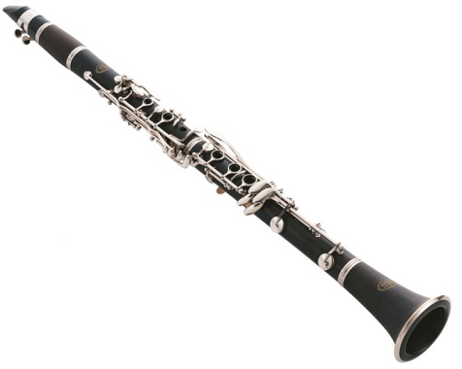
Clarinet is a long slender black tube with a flarred bell and metal keys. It uses a single reed. The most popular one is the B-flat clarinet. The clarinets in B flat and A are the standard orchestral instruments. The higher, shriller E flat clarinet is also a band instrument and is used occasionally in the orchestra. There are 2-4 clarinets in an orchestra. A standard clarinet is 26 inches long. To play it, we hold the clarinet in an up and down position, put the mouthpiece and the reed in our mouth and blow. We use both hands to press on the keys to open and close the holes and change the pitch of the sounds.
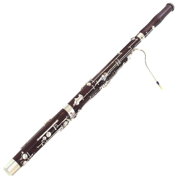
The bassoon is a long tube, folded in half with lots of metal keys. The fold makes it easier to play. The bassoon has a double reed and a long, slim, curved mouthpiece. There are 2-4 bassoons in an orchestra. To play it, we hold the bassoon in an up and down position, put the double reed in our mouth and blow. The air travels down the tube and then makes a u-turn and goes up and out the top. We use both hands to press on the keys to open and close the holes and change the pitch of the sound.

- Strings
Half of the orchestra are made up from the string family. Most of the string family look similar, but they have different sound and size. All instruments from this family have strings, which are made of gut, steel or nylon.We play the string instruments by drawing a horsehair bow across the strings or by plucking or tapping the strings. This creates a vibration that causes a unique sound. All of the string instruments, except for the harp, have curly hollow wwoden bodies and long necks, The strings are streched from pegs at the top of the neck, over the body, and down to the tailpiece. They play the most melody in an orchestra, that what makes them different from the others. Here are some of them.
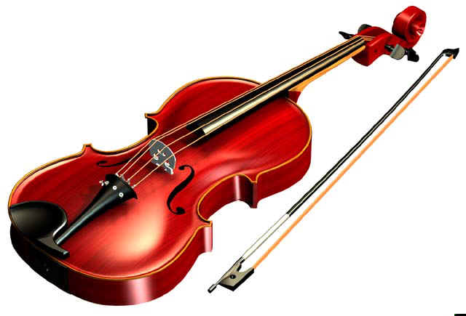
Violin is the smallest instrument in this family. It also has the highest pitch of the string family. The sound of the violin is high, bright and sweet. There can be 30 or more violins in an orchestra. Violins get divided into 2 groups : first and second. First violins often play the melody. A standard violin is around 24 inches long. The violin is around 29 inches long. We play the violin by tucking it between our chin and shoulder. The left hand presses down on the strings to change the pitch, and the right hand mives the bow or plucks the strings.

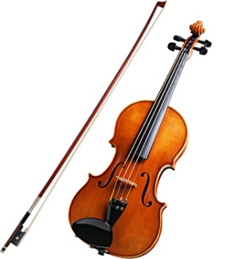
Viola looks like violin but it’s a bit larger in size and lower in pitch that the violin. It also has deeper and warmer sound than the violin. The tone is deeper and less brilliant that that of the violin. It is used mainly in the orchestra and chamber music, but recently has become increasingly popular as a solo instrument. There are 10 – 14 violas in an orchestra. A standard viola is around 27 inches long. The bow is around 29 inches long. It’s a little thicker and heavier than a violin bow, since the strings of the viola are a little thicker than the violin’s strings. We play it just the same with the way we play the violin.
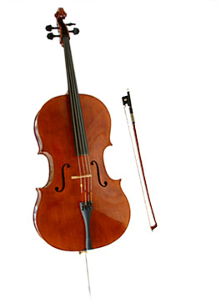
Originally cello called violoncello. Cello looks like violin, but it’s much larger with a shorter neck and a lower pitch. Its size is twice as large as the violin and has four strings tuned an octave lower than those of the viola. The cello makes a wide range of beautiful sounds, from warm low notes to rich high notes. There are 8 – 12 cellos in an orchestra. A regular orchestra is around 4 feet long. The cello bow is over 28 inches long and it’s thicker than a viola bow. Because the cello is too big, so when we play it we have to sit in a chair with the body of the cello between our knees and with the neck of the cello on our left shoulder. The cello rests on the ground, supported by a metal peg. With our left hand, we press down on the strings to change the pitch and with our right hand, we move the bow or pluck the strings.
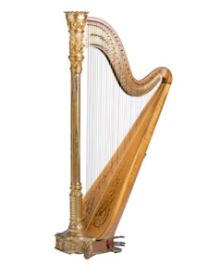
The harp is a large instrument with 47 strings, which are stretched across a wooden frame. The bottom part of the wooden frame is hollow.There are 1 or 2 harps in an orchestra.A standard harp is 6 feet tall and weighs 80 to 90 pounds.To play it, sit down with your legs on either side of the harp. The harp leans slightly on your right shoulder. Each string sounds a different note and you play them using one hand on each side of the strings. You pluck and brush across the strings with your fingertips and thumb.

- Brass
The instruments in this family are really made by brass. They can play the loudest of all instruments in the orchestra. Basically, they are very long tubes with flared ends called “bells.” The brass family consists of 4 major instruments with many other similar variations on them. The Trumpet/Cornet, the French Horn, the Trombone, and the Tuba/Sousaphone. Sound is produced by each instrument in the family by buzzing the lips together into the mouthpiece. These instruments are a part of the band program, along with the woodwinds family and the percussion family. Brass tubes have been curved and shaped to make them easier to hold. The difference of this family compared to the others are their shape and their material that used to make these instruments, which is brass. Here are some of them.

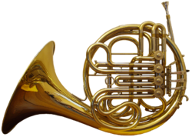
French horn is a horn and it came from France. It was used as a hunting horn in France in the second half of 17th century. It's a long slender metal tube, about 17 feet long, curved around and around, with a large bell at the end. French horns are made as “single” horns or “double” horns or sometimes as a rarely seen “triple” horn. The simplest beginning horn is a single horn which can come in two sizes, either a Bb (“B” flat) or an “F” horn. In modern orchestras it is usually in the key of F and is a transposing instrument. The present-day French horns normally have three valves. There are usually 4 French horns in an orchestra, but there can be as few as 2 and as many as 8. You play the French horn by holding it with the bell curving downward and buzzing into the mouthpiece. Your left hand plays the three valves and your right hand moves in and out of the bell to change the sound. For a louder effect, you play with the bell up, instead of down.

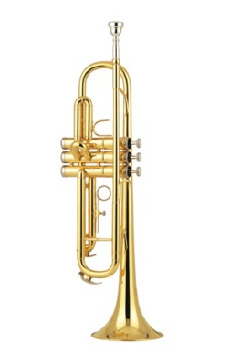
The trumpet has been around for a very long time. People have been playing trumpet-like instruments made of conch-shell, horn, wood or metal, for thousA standard modern trumpet is a long slender metal tube with three valves. It’s bent into a paper clip shape, but if you stretched it out, it would be 6 1/2 feet long.ands of years. The trumpet plays the highest pitches of the brass family. Its sound is bright, brilliant, and exciting. There are 2-4 trumpets in an orchestra.You play the trumpet by holding it horizontally, buzzing into the mouthpiece, and pressing the three valves in various combinations to block or divert air down the tubes. A transposing instrument, it is now most often in B flat. A bass trumpet in C was first called for by Wagner. The trumpet is an important member of most dance and jazz bands. Advanced players may have a trumpet and a cornet and several other sizes of trumpets. They may perform on a “C” trumpet, “D” trumpet or even a piccolo trumpet. The most common version is a Bb (“B” flat) trumpet or cornet. All beginning trumpet players should start on a Bb instrument.
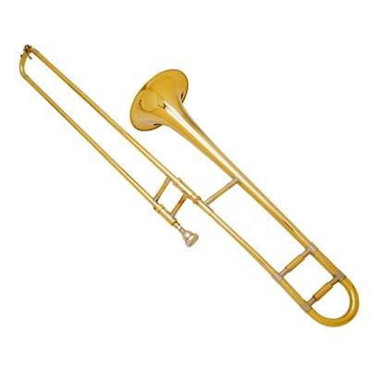
The trombone is a powerful and unique instrument. Instead of having valves, the trombone uses its sliding shape to change sounds. A standard trombone is made of long slender metal tubes. Two U-shaped tubes are linked at opposite ends to form an "S." One tube slides into the other so the overall length of tube can be extended or shortened at will. If you add up all the tubing, the trombone is around 9 feet long. There are usually three trombones in an orchestra and they often play together as a trio. To play it, you hold the trombone horizontally and buzz into the mouthpiece. With your right hand, you push and pull the sliding piece to change the length of the tube, which changes the pitch of the sounds. Almost all trombones come in just one size. Several have the optional “F” attachment but the instrument plays in the same way as a trombone without an “F” attachment. The “F” trigger just allows a player more alternate slide positions for difficult passages. Three trombones are standard in the orchestra, formerly alto, tenor, and bass. The tenor is most often used today, often with extra tubing that can be cut in by a valve to give it the lower notes of the old bass trombone. The trombone is also widely used in jazz and dance bands. A valved trombone, first produced in Vienna in the 1820s, is frequently used in Latin countries, and by some jazz musicians, but is inferior in tone quality to the slide trombone.

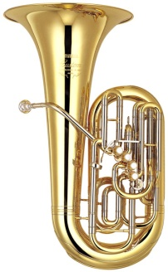The tuba is the largest brass instrument and has the lowest pitch. The tuba is a long metal tube, curved around and around, with a huge bell at the end. There are many sizes of tubas ranging from 9 to 18 feet of tubing. The longer the tubing, the lower the pitch. Standard tubas have about 16 feet of tubing. The tuba makes very deep, low, and rich sounds. There is usually one tuba in an orchestra. To play it, you usually sit down with the tuba on your lap and the bell facing up. You blow and buzz into a very large mouthpiece and use your hand to press on the valves which changes the sound. There are “CC” tubas, Eb (“E” flat) tubas , BBb tubas and F tubas.

- Percussions
Percussions are any instrument that produces musical sound when its surface is struck with an implement (such as a mallet, stick, or disk) or with the hand. Perhaps the most universally familiar percussion instrument is the drum, common to the most primitive as well as the most sophisticated musical arts. Sticks clicked against each other are another simple form of percussion. The Percussion family is an interesting case, because every member of the percussion section in band must play every instrument in the section. To play it, we hit it, shake it or scrape it. What makes this family different from the others is some instruments of this family don’t play melody. Here are some of them.

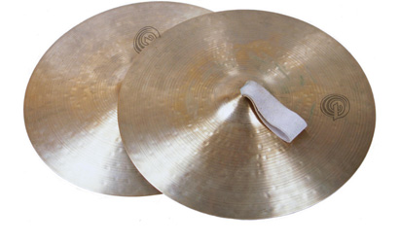
Cymbals look like a pair of gold-colored pot lids. But actually these concave brass plates are sophisticated instruments. Cymbals don’t play specific notes. The size of cymbals determines the sounds they make. They range from very small and high, to very large and low.
The sound of cymbals can be used for drama and excitement, rhythm, or delicate sound effects. You play the cymbals by either hitting one cymbal against the other cymbal, or you use sticks, mallets or brushes to hit one or both cymbals. Regardless of what you use to hit them, you can make a range of loud and soft sounds. In the orchestra, cymbals have leather handles and are clashed by sweeping them past each other sideways or played by means of a foot pedal. A single cymbal may be struck by wooden or felt drumsticks. Small antique cymbals, used in orchestral scores by Debussy, yield a more definite pitch.

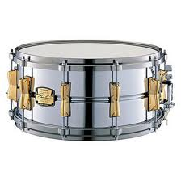The Snare Drum is the smallest drum in the percussion section. This is the most popular drum and is used in nearly all styles of music. It’s a drum with a snare. A snare is a set of wires that sit outside of the bottom drumhead and make a rattling sound when you hit the drum. A standard snare drum is a hollow cylinder with two drumheads stretched over it, one on the top and one on the bottom. The drumheads are made of calfskin or plastic. The snare drum is an untuned drum, so it doesn’t play distinct notes. Snare drums are used to keep the rhythm and make special sounds, such as drumrolls. You play the snare drum by hitting the top with sticks, mallets, or brushes.

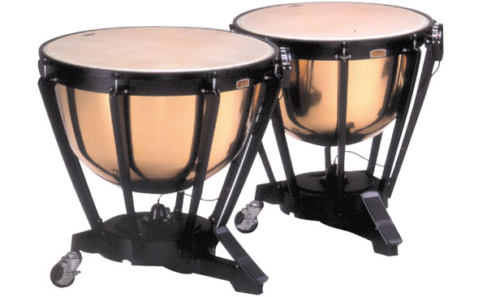
Timpani are easy to spot because they look like big shiny bowls or upside-down tea kettles, which is why they’re also known as kettledrums. Timpani are large metal pots with drumheads stretched over their tops. The drumheads are made of calfskin or plastic. Timpani are tuned, which means they can play different notes. You change the note they sound by stretching or loosening the drumheads, usually by pressing a pedal. Timpani are an extremely important part of the percussion family. They can help keep the rhythm and support the melody. Most orchestras have four timpani of varying sizes and pitches, usually played by one musician. You play timpani by hitting the drumheads with felt-tipped mallets or wooden sticks.

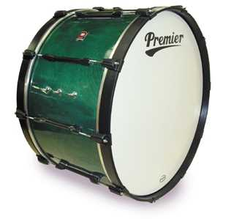
This is a big one, the biggest drum in the percussion family. The bass drum is untuned and is similar in shape to the snare drum, but without the snare.A standard bass drum is a large hollow cylinder with drumheads stretched over both sides. The bass drum makes the lowest sounds in the percussion family and is used for rhythm and mood. It can make a range of sounds from thunder to whispers.You play the bass drum by hitting either side of the drum with sticks that have large soft heads, often covered with sheepskin or felt.

BIBLIOGRAPHY
Beginning Band- School Band and Orchestra Information. Web. 30 Jan. 2012. <http://www.beginband.com>.
"Families of Musical Instruments — FactMonster.com." Fact Monster: Online Almanac, Dictionary, Encyclopedia, and Homework Help — FactMonster.com. Web. 30 Jan. 2012. <http://www.factmonster.com/>.
Music Tech Teacher. Web. 30 Jan. 2012. <http://musictechteacher.com>.
San Fransisco Symphony. Web. 30 Jan. 2012 <http://sfskids.org>.

